**WATER MONITORING SYSTEM**

BY

|  |  |  |
| --- | --- | --- |
| Name of Students: | Class | Roll No. |
| VINEET RAMDAS AROTE | BE 5 | 32 |
| SAHEB SINGH MATTA | BE 5 | 68 |
| MANAV MEHTA | BE 5 | 70 |
| AKSHAY NALAWADE | BE 5 | 73 |

**Guide:**

Prof. ARCHANA CHAUGULE



**Department of Information Technology**

**Shah and Anchor Kutchhi Engineering College, Mumbai**

**2018-2019**

# TABLE OF CONTENTS

|  |  |
| --- | --- |
| **TITLE** | **Page No.** |
| Abstract | 3 |
| Abbreviation | 4 |
| Introduction | 5 |
| Summary | 6 |
| References | 9 |
| Acknowledgement | 10 |

# ABSTRACT

Water is always a crucial part of everyday life. Due to global environmental situation, water management and conservation is vital for human survival. In recent times, there were huge needs of consumer-based humanitarian projects that could be rapidly developed using Internet of Things (IoT) technology. This IoT based water monitoring system that measures water level, temperature and flow rate in real-time. Our prototype is based on the idea that measuring the flow rate can enable you to be billed according to your usage and play a huge part in reducing water wastage. A cloud server was configured as data repository, the data is sent to the cloud using a GSM sim messaging system. The real-time measurement of the water level, temperature and flowrate are displayed in remote dashboard.

# ABBREVIATION

* **GSM:**

Global System for Mobile Communications

* **LED:**

Light Emitting Diode

* **GPRS:**

General Packet Radio Service

* **RTC**

Real Time Clock

* **SD Card:**

Secure Digital Card

* **IR Temperature Sensor:**

Infrared Temperature Sensor

# INTRODUCTION

Water Monitoring System is aimed towards tackling the water crisis of India. Wastage and misuse of water in major cities is a growing cause of concern not only for present generation but for the future as well. This project aims to limit the wastage and misuse of water by monitoring the usage and billing the user accordingly. This project aims at monitoring water consumption in each household and generate a bill accordingly. In most societies there is a collective water bill where all members pay equally irrespective of usage, this project aims to bill individual members according to their usage. This project also aims to monitor the water level in the supply tank and the temperature. In case the water temperature nears freezing point, it will alert the user to heat the water. Level monitoring can be used to measure the water in the tank and to automatically fill the tank from the supply tank, once the water level reaches below a certain set limit, this reduces the risk of water overflowing. It has a start/stop system for which the water supply can stop once the upper limit of water usage is reached for a consumer. The consumer pays for the amount of water needed and once the amount is reached the connection is automatically stopped.

# SUMMARY

The Water Monitoring System aims to reduce water wastage and mismanagement by live monitoring the water tanks and billing each consumer according to their respective consumption. This will create awareness for water consumption and also show the consumers how much water they are wasting due to mismanagement. The features and objectives of this project are given below.

**Features:**

1. Live Temperature Monitoring.
2. Water Level Monitoring.
3. Water Flow-Rate Monitoring
4. Water Flow Control using SMS.

**Objectives:**

1. Live Temperature Monitoring:
   * + The water temperature is monitored in real-time to provide users an exact or approximate value.
     + This will allow the user to know what temperature the water is and this enables the user to heat/cool the water as required for use.
     + This will also help to alert the user if the water temperature goes above or below a particular temperature during summers and winters respectively.
2. Water Level Monitoring:
   * + The water level is monitored to notify the user about the level of water in the primary and secondary tank.
     + This will help the user know if any of the tank empty or filled to the completely.
     + This can remotely be used to pump water to fill the tank if any of them is empty. This process can be done automatically when the water level in a tank reached below a certain mark or, it can notify the user and the user sends a SMS to fill the tank.
3. Water Flow-Rate Monitoring:
   * + The water flow rate will be monitored to track the amount of water used by the consumer.
     + This will help the user track their water usage and make necessary adjustments as required.
     + This will help in maintaining a record of consumption of each consumer so that a bill can be generated for the user.
     + This will help in spreading awareness about water wastage to the consumer and aid in proper management of water consumption.
4. Water Flow Control using SMS:

* The flow will be controlled remotely through SMS.
* This will help the water suppliers control the supply of water to their consumers.
* Since the supply can be billed according to consumer consumption, this will help suppliers disconnect supply to those whose water quota is used (For prepaid users) and/or to those who have outstanding bills (For Postpaid users)

**Block Diagram:**

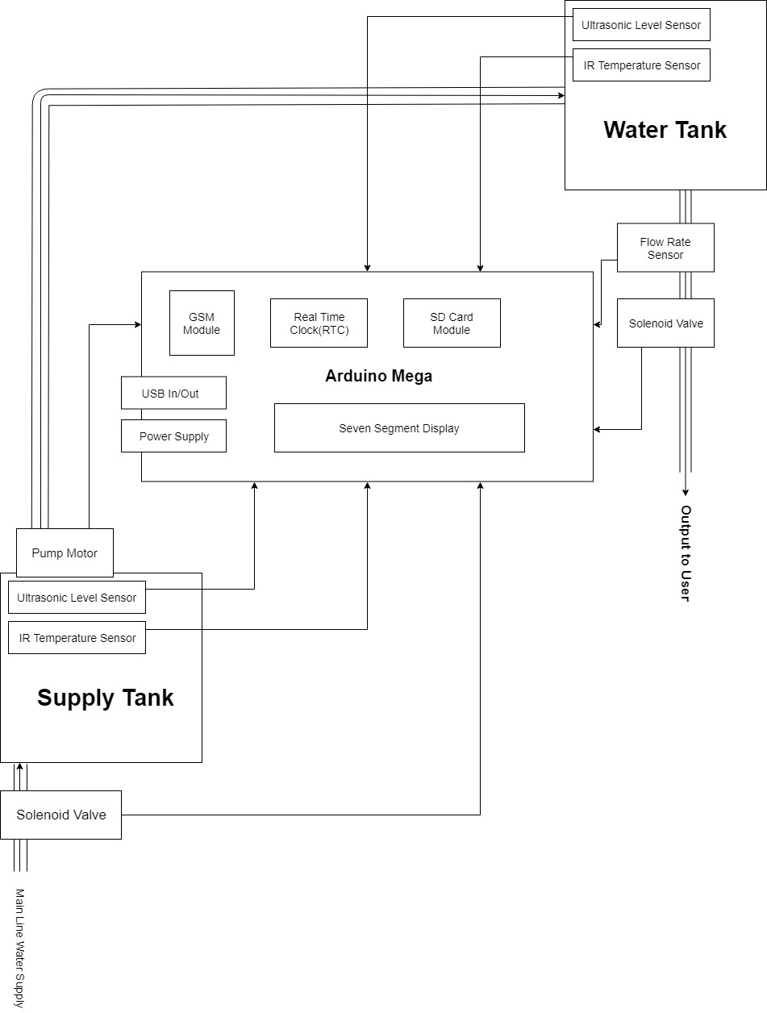

# REFERENCES

* IEEE Paper: Internet of Things (IoT) enables water monitoring system:

<https://ieeexplore.ieee.org/document/7398710/>

* <https://en.wikipedia.org/wiki/Water_scarcity_in_India>
* <https://economictimes.indiatimes.com/news/politics-and-nation/india-stares-at-water-crisis-urgent-steps-needed-experts/articleshow/63828947.cms>
* <https://www.rlf.org.uk/resources/the-structure-of-a-literature-review/>

# ACKNOWLEDGEMENT

We would like to thank **Professor Archana Chaugule Ma’am** for her expert advice, encouragement and patience till date for this project.

We would like to thank **Mr. Nilesh Sahare Sir** for his support and Guidance regarding the project.

We would thank our Head of Department **Professor Swati Nadkarni Ma’am** for giving us the opportunity to work on this project.